# Introduction

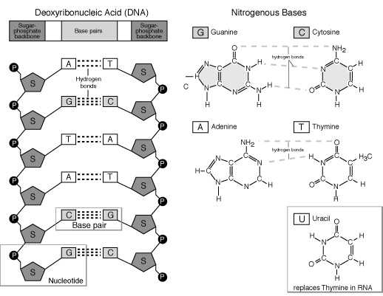Deoxyribonucleic acid(DNA) is composed of four bases: adenine(A), thymine(T), guanine(G) and cytosine(C). A is paired with T(2 H-bonds) and G is always paired with C(3 H-bonds). The order of these base pairs determine the polypeptide that the DNA section codes for – so DNA is vital to the living processes of an organism. Over 99% of base orders are shared with humans around the world. The DNA double helix is essentially two strands of nucleotides, held together by hydrogen bonds between base pairs. A nucleotide is a monomer unit of DNA, consisting of a sugar-phosphate backbone linked to a base[1].

Figure

In 1953, *Nature* magazine published Francis Crick and James Watson’s breakthrough paper: “A Structure for Deoxyribose Nucleic Acid ,” which detailed the double helix structure of the DNA molecule. It should also be noted that their research was aided by the work of Rosalind Franklin and Maurice Wilkins in the X-ray crystallography imaging of the DNA molecule. Franklin’s game-changing ‘photo 51’ completed the jigsaw for Crick and Watson, and they finally concluded that DNA exists as a double helix rather than the previously thought single helix[5].

It would become known that certain sections of the DNA double helix would code for different polypeptides – these ‘sections’ are referred to as genes. The polypeptide is in fact a polymer of amino acid monomers – the type of protein is determined by the type and order of amino acids that it is made up of. And the order of amino acids is controlled by the genetic base order – with three bases(codon) coding for each amino acid. For example, the codons: TCA and GTC correspond to the amino acids serine and valine, respectively. So if the base order on a DNA molecule was: TCAGTCTCA, then the coded polypeptide chain would contain serine-valine-serine linked in their respective order. However, there are some amino acids that have numerous codons – such as arginine, which is coded by CGC, CGG, CGT and CGA[2].

# Replication

## Mitosis

The chromosomes become duplicated during the interphase, then during prophase the chromosomes retract and condense – this causes them to become visible under a microscope. At this point centrioles generate spindles which attach to the centromeres of the homologous pairs and the nuclear membrane breaks down. The homologous pairs of chromosomes line along the equator of the cell during the metaphase stage, then during anaphase, the spindles contract so that each 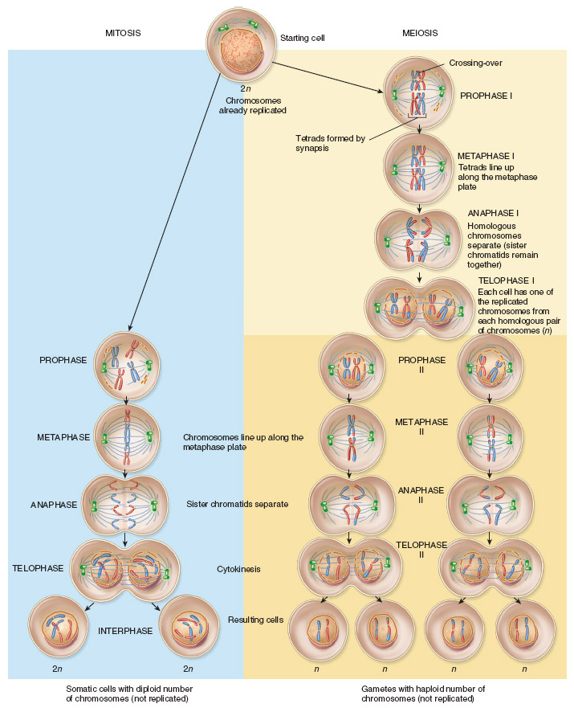chromosomal copy moves to each cell pole. The final telophase stage is defined by the nuclear membrane forming around the copied chromosomes and cytokinesis, where the cytoplasm cleaves and separates to form 2 genetically identical daughter cells[6].

Figure

## Meiosis

Meiosis plays an important role in the formation of gametes. During the interphase stage, the DNA is replicated to form a diploid cell. In total, 2 sets of cell division occur, and these are defined by 2 sets of the following four stages(in order): Prophase>Metaphase>Anaphase>Telophase.

### Prophase I

During DNA replication the chromosomes had unravelled, however for the next stage they need to be in compact, efficiently translatable form, so they condense in volume. Homologous pairs of chromosomes line up besides each other and their chromatids crossover. This effectively transfers genetic material between the non-sister paternal and maternal chromatids within each pair, so that they now have different alleles. Centrioles move to the poles of the cell and begin generating protein fibres called spindles, and the nuclear envelope disintegrates.

### Metaphase I

The spindle fibres attach to the centromeres of the homologous pairs of chromosomes, which have since lined up along the metaphase plate on the equator of the cell.

### Anaphase I

The contraction of the spindle fibres causes the chromosomes within each pair to be pulled apart, and moved to the poles of the cell.

### Telophase I

The nuclear envelope reforms around the now divided genetic material in either end of the cell, and the cytoplasm cleaves, finally causing the cell to divide into two haploid daughter cells with half the number of chromosomes.

### https://upload.wikimedia.org/wikipedia/commons/thumb/9/9d/Diagram_Damage_to_Cancer_Wiki_300dpi.svg/2000px-Diagram_Damage_to_Cancer_Wiki_300dpi.svg.pngSecond Stage of Meiosis

Figure

The 4 processes above are repeated for the two haploid daughter cells. Presence of half the genetic material than before means that during Anaphase II, the spindle fibres contract to separate the sister chromatids from each other. This has the result of each of the 4 daughter cells having inherited a chromatid from each chromosome, it is due to this independent assortment of chromatids that each gamete has a unique combination of alleles[2].

# Changing DNA

The DNA double helix changes during cell replication, or ‘mitosis.’ During the prophase stage, the DNA double helix becomes unstranded by and free nucleotides bond with their corresponding base pairs on the recently ‘unzipped’ DNA helix. This results in the formation of a replicated DNA double helix. After the chromasomes align along the equator of the cell, spindles pull apart the chromasomes from their homologous pairing, thus separating the copies and moving them towards the cell poles.

Occasionally mistakes occur during the replication stage; base pair orders may be incorrectly assembled – this leads to variation in the genetic code. Variation can be beneficial to the individual, such as a mutation to generate proteins that allow for better perception of light and dark, thus better eyesight. However, the disadvantages of mutations arise when the peptide the DNA originally coded for, cannot be further synthesised – leading to deabilitating conditions such as cystic fibrosis. This is caused by 3 bases becoming deleted in the cystic fibrosis transmembrane conductance regulator(CTFR) protein gene. In sufferers, the CTFR protein does not form properly with incorrect folding, leading to excess mucus and breathing difficulties[2].

More often though, a ‘typo’ in DNA synthesis does not cause a significant issue, as the code can still be inerpreted just the same as without the typo. Especially if the mistake has occured in ‘junk DNA’[3]. Junk DNA can be defined as a sequence of base nucleotides that do not code for anything, it does not include genes and is not capable of direct involvement in protein synthesis. Such mutations have a neutral effect, for example, the base orders TAT and TAC both code for tyrosine, so the deletion of 1 base will not affect protein synthesis. The same applies for lysine and arginine which are coded by AAG and AGG, respectively. Both amino acids have similar chemical properties so will have a neutral affect on the final protein tertiary structure[2,4].

Sections of DNA need to be transcripted into RNA strands for protein synthesis; a polynucleotide strand of RNA can easily leave the nucleus through a nuclear pore to reach a ribosome where protein is synthesised, but DNA cannot. When free nucleotides line alongside a template DNA strand, by the action of the enzyme RNA polymerase, adenine(A) is paired with uracil(U) rather than thymine(T). This process forms the messenger RNA(mRNA) strand which leaves the nucleus and binds to a ribosome.

The next stage in protein synthesis is translation: transfer RNA(tRNA) molecules, which are bonded to an amino acid, float towards the ribosome. Each tRNA molecule has an anticodon for every codon on the mRNA strand – that is to say, an mRNA codon of CGU would be complementary to a GCA anticodon on the tRNA. As the ribosome moves along the mRNA strand, the complementary base pairs cause 2 tRNA molecules to attach to mRNA, effectively causing a covalent peptide bond to form between the adjacent amino acids. The first tRNA molecule detatches and floats away, while another attaches next to the last one. The process of a tRNA molecule attaching to mRNA, a peptide bond forming, and the tRNA disconnecting from the mRNA continues until a polypeptide forms.

Certain synthesised polypeptides do not carry out a function until they have been “activated.” This is usually influenced by molecules such as hormones, but may be affected by synthetic chemicals from drugs. Some molecules initiate the relay of secondary messenger such as cyclic adenosine monophospate or cAMP, which activates peptides inside the cells. One such peptide is protein kinase A (PKA), which is a 4 subunit enzyme involved in deactivating other proteins by phosphorylating them. It has 2 subunits that contain binding sites for cAMP, and when cAMP does bind with them it causes the three dimensional tertiary structure of the protein to change, thus rendering it in a state where it is activated and can carry out a particular function. In the case of PKA, this means losing 2 subunits[2].

# Environmental Factors

# How cancer arises

# Which diseases do the chromosomes code for?

While some disorders require two recessive alleles to have been inherited for the disorder to be expressed in the phenotype, others are codominant and both alleles are expressed.

## Sickle-cell anaemia

The allele that codes for sickle-cell anaemia is codominant, meaning that if one is homozygous for sickle-cell anaemia then all of their red blood cells will be deformed into a sickle shape. However if an individual is heterozygous for sickle-cell anaemia, then their phenotype will be characterised by both normal and sickle-shaped red blood cells. The genetic diagram on the right depicts the possibilities of inheriting sick-cell anaemia[2].

## Colour blindness

Colour blindness is a gender-linked disorder that is carried as a recessive allele on the X-chromosome. Since males have 1 Y and 1 X chromosome, if their mother is a carrier of the colour blindness allele, then they have a 50% chance of inheriting the disorder. Alleles that are involved in functioning colour vision are not on the smaller Y-chromosome. Conversely, the X-chromosome is much larger and thus contains more genes. So in most gender-linked diseases, females are more likely to be carriers whereas males have a higher chance of having disease expressed in their phenotype. In the case of colour blindness, this means that males only require 1 recessive colour blindness allele to suffer from it, whereas females require 2 alleles[2].

# http://m.patient.media/images/283.gifReferences:

Figure

[1] - <https://ghr.nlm.nih.gov/primer/basics/dna>

[2] – A2 Level Biology, Exam Board OCR, Complete Revision and Practise, CGP, 2009.

[3] - <https://www.my46.org/intro/how-does-dna-change>

[4] - <http://www.nytimes.com/2015/03/08/magazine/is-most-of-our-dna-garbage.html?_r=0>

[5] - <http://wellcomelibrary.org/collections/digital-collections/makers-of-modern-genetics/digitised-archives/rosalind-franklin/>

[6]- <https://publications.nigms.nih.gov/insidethecell/ch4_phases_allbig.html>

# Images:

Fig. 1 – http://ircamera.as.arizona.edu/Astr2016/text/nucleicacid1.htm

Fig. 2 – http://higheredbcs.wiley.com/legacy/college/tortora/0470565101/hearthis_ill/pap13e_ch03_illustr_audio_mp3_am/simulations/figures/compare_mm.jpg

Fig. 3 – https://upload.wikimedia.org/wikipedia/commons/thumb/9/9d/Diagram_Damage_to_Cancer_Wiki_300dpi.svg/2000px-Diagram_Damage_to_Cancer_Wiki_300dpi.svg.png

Fig. 4- http://m.patient.media/images/283.gif